FALCON: Supplementary Dataset, Implementation, and Reproducibility Details
Dataset Details
We use the eICU Collaborative Research Database (eICU-CRD) for in-hospital mortality prediction. We analyze 10 hospitals to characterize cross-hospital heterogeneity, with five hospitals (167, 199, 252, 420, and 458) used as federated clients in the primary strict LOHO experiments.

The eICU Collaborative Research Database (eICU-CRD) is hosted on PhysioNet.
- Main Database Link: eICU Collaborative Research Database on PhysioNet
- Official Documentation & Website: eICU-CRD Documentation Portal

To gain access to eICU dataset,
- Create an Account: Register for a user account on PhysioNet.org.
- Complete Human Subjects Training: Take and pass an approved ethics course, such as the CITI Data or Specimens Only Research or Information Privacy Security (IPS) course.
- Submit Access Request: Go to the eICU-CRD project page on PhysioNet, click Request Access, upload your training certificate, and provide a professional or academic reference.
- Sign the Data Use Agreement (DUA): Agree electronically to strict data protection rules, including strict non-reidentification and non-redistribution commitments.
- Receive Approval & Access: Upon manual review and approval by PhysioNet, query or download the full dataset via PhysioNet, Google BigQuery, or AWS.
As shown in Table 1, the hospitals exhibit substantial non-IID variation. Patient populations range from 2,097 patients at Hospital 283 to 6,092 patients at Hospital 167, while mortality prevalence varies from 4.03% to 9.36% across institutions. Demographic characteristics, including sex, ethnicity, and obesity prevalence, also differ considerably. In addition, variations in mean Lactate and Blood Urea Nitrogen (BUN) values indicate physiological covariate shifts across hospitals. These differences provide a realistic setting for evaluating FALCON under heterogeneous clinical distributions.
Input features include demographics, laboratory measurements, medications, diagnosis and treatment information, and clinical time-series representations. This table summarizes the demographic and clinical heterogeneity across the 10 hospitals.
Hospital | Patients | Mortality(%) | Male (%) | Caucasian (%) | Obese(%) | Mean Lactate | Mean BUN
167 | 6092 | 4.22 | 55.50 | 80.30 | 28.90 | 1.69 | 20.77
420 | 4679 | 9.36 | 58.10 | 93.60 | 34.40 | 1.73 | 24.27
199 | 4240 | 6.32 | 56.00 | 97.20 | 44.00 | 1.76 | 23.36
458 | 3701 | 9.05 | 55.10 | 69.50 | 37.30 | 1.83 | 22.60
252 | 3371 | 9.26 | 57.50 | 93.20 | 39.90 | 1.80 | 22.55
165 | 3053 | 4.42 | 53.60 | 87.30 | 30.30 | 1.69 | 20.04
148 | 2881 | 4.03 | 53.70 | 94.90 | 28.60 | 1.67 | 23.16
281 | 2531 | 5.29 | 53.10 | 84.60 | 39.50 | 1.67 | 23.65
449 | 2110 | 7.58 | 54.90 | 92.20 | 37.10 | 1.93 | 22.91
283 | 2097 | 6.01 | 50.90 | 95.20 | 32.00 | 1.62 | 26.45

Table 1. Demographic and clinical heterogeneity across hospitals

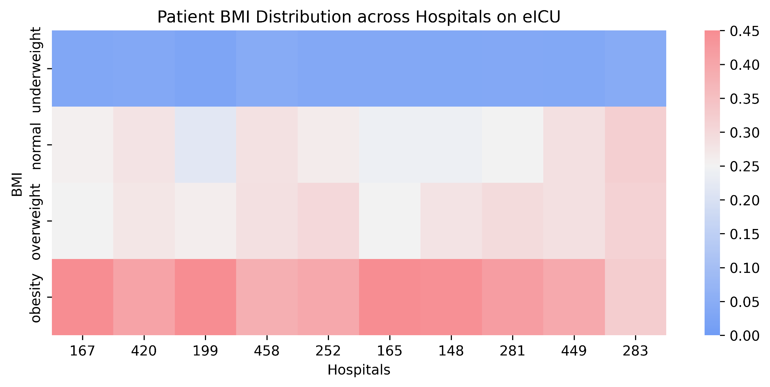 | 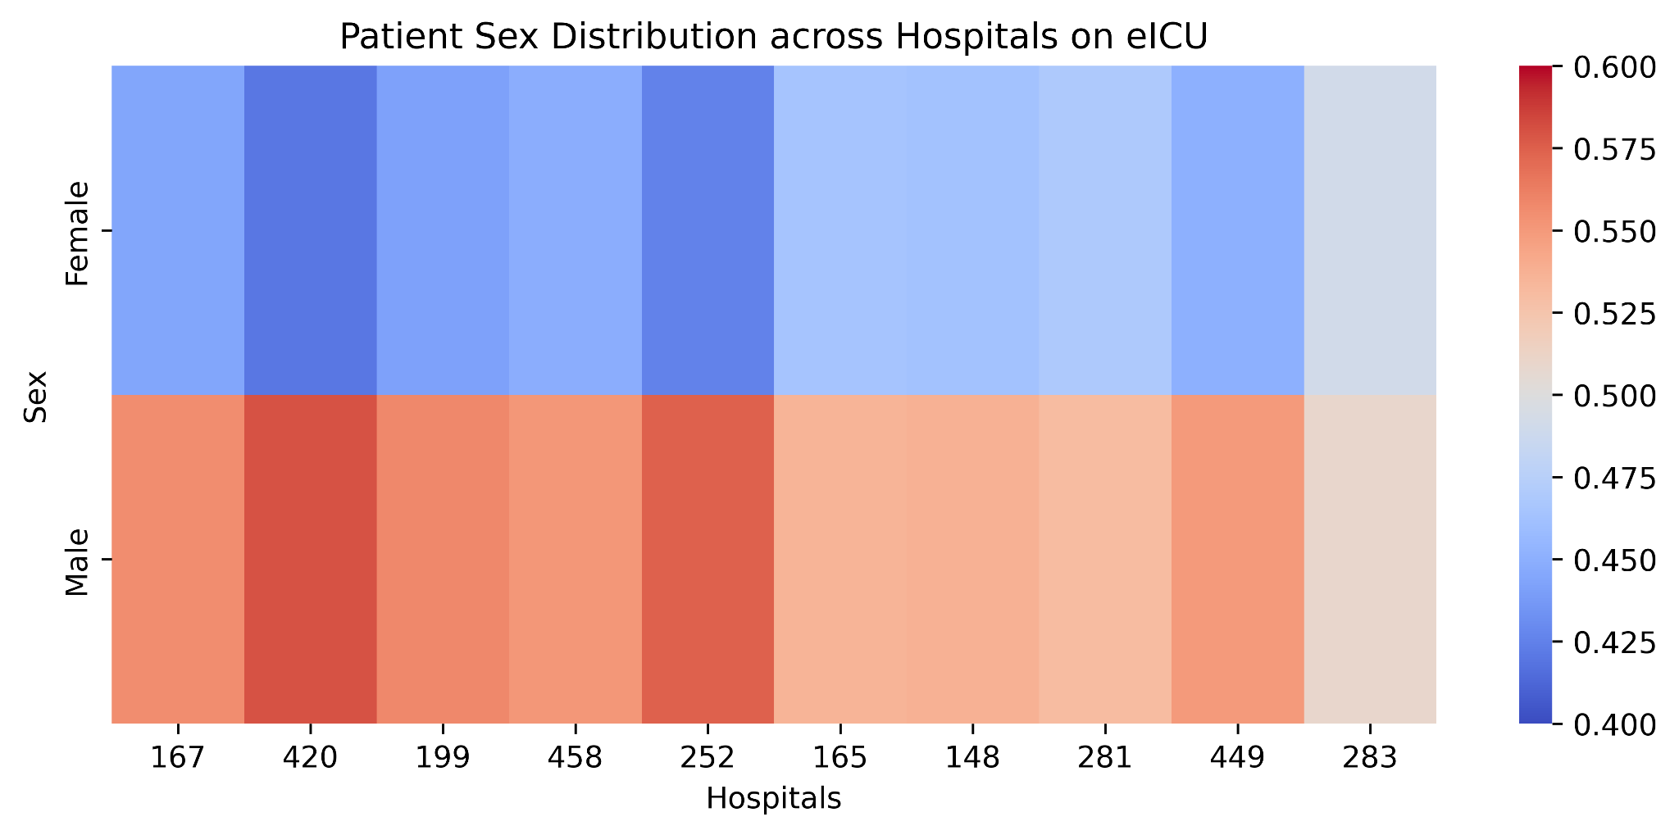
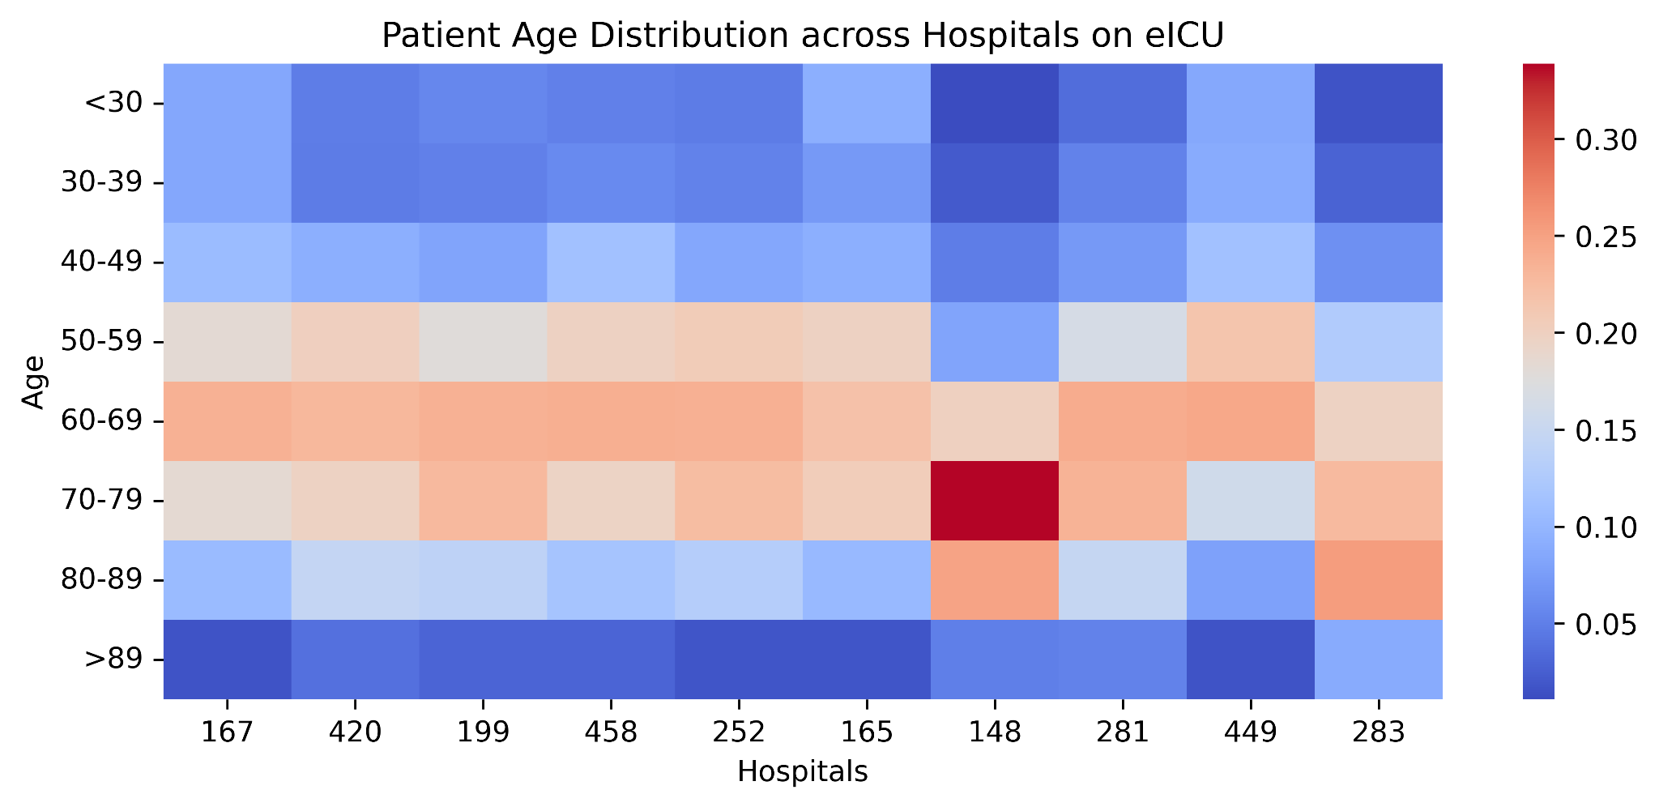 | 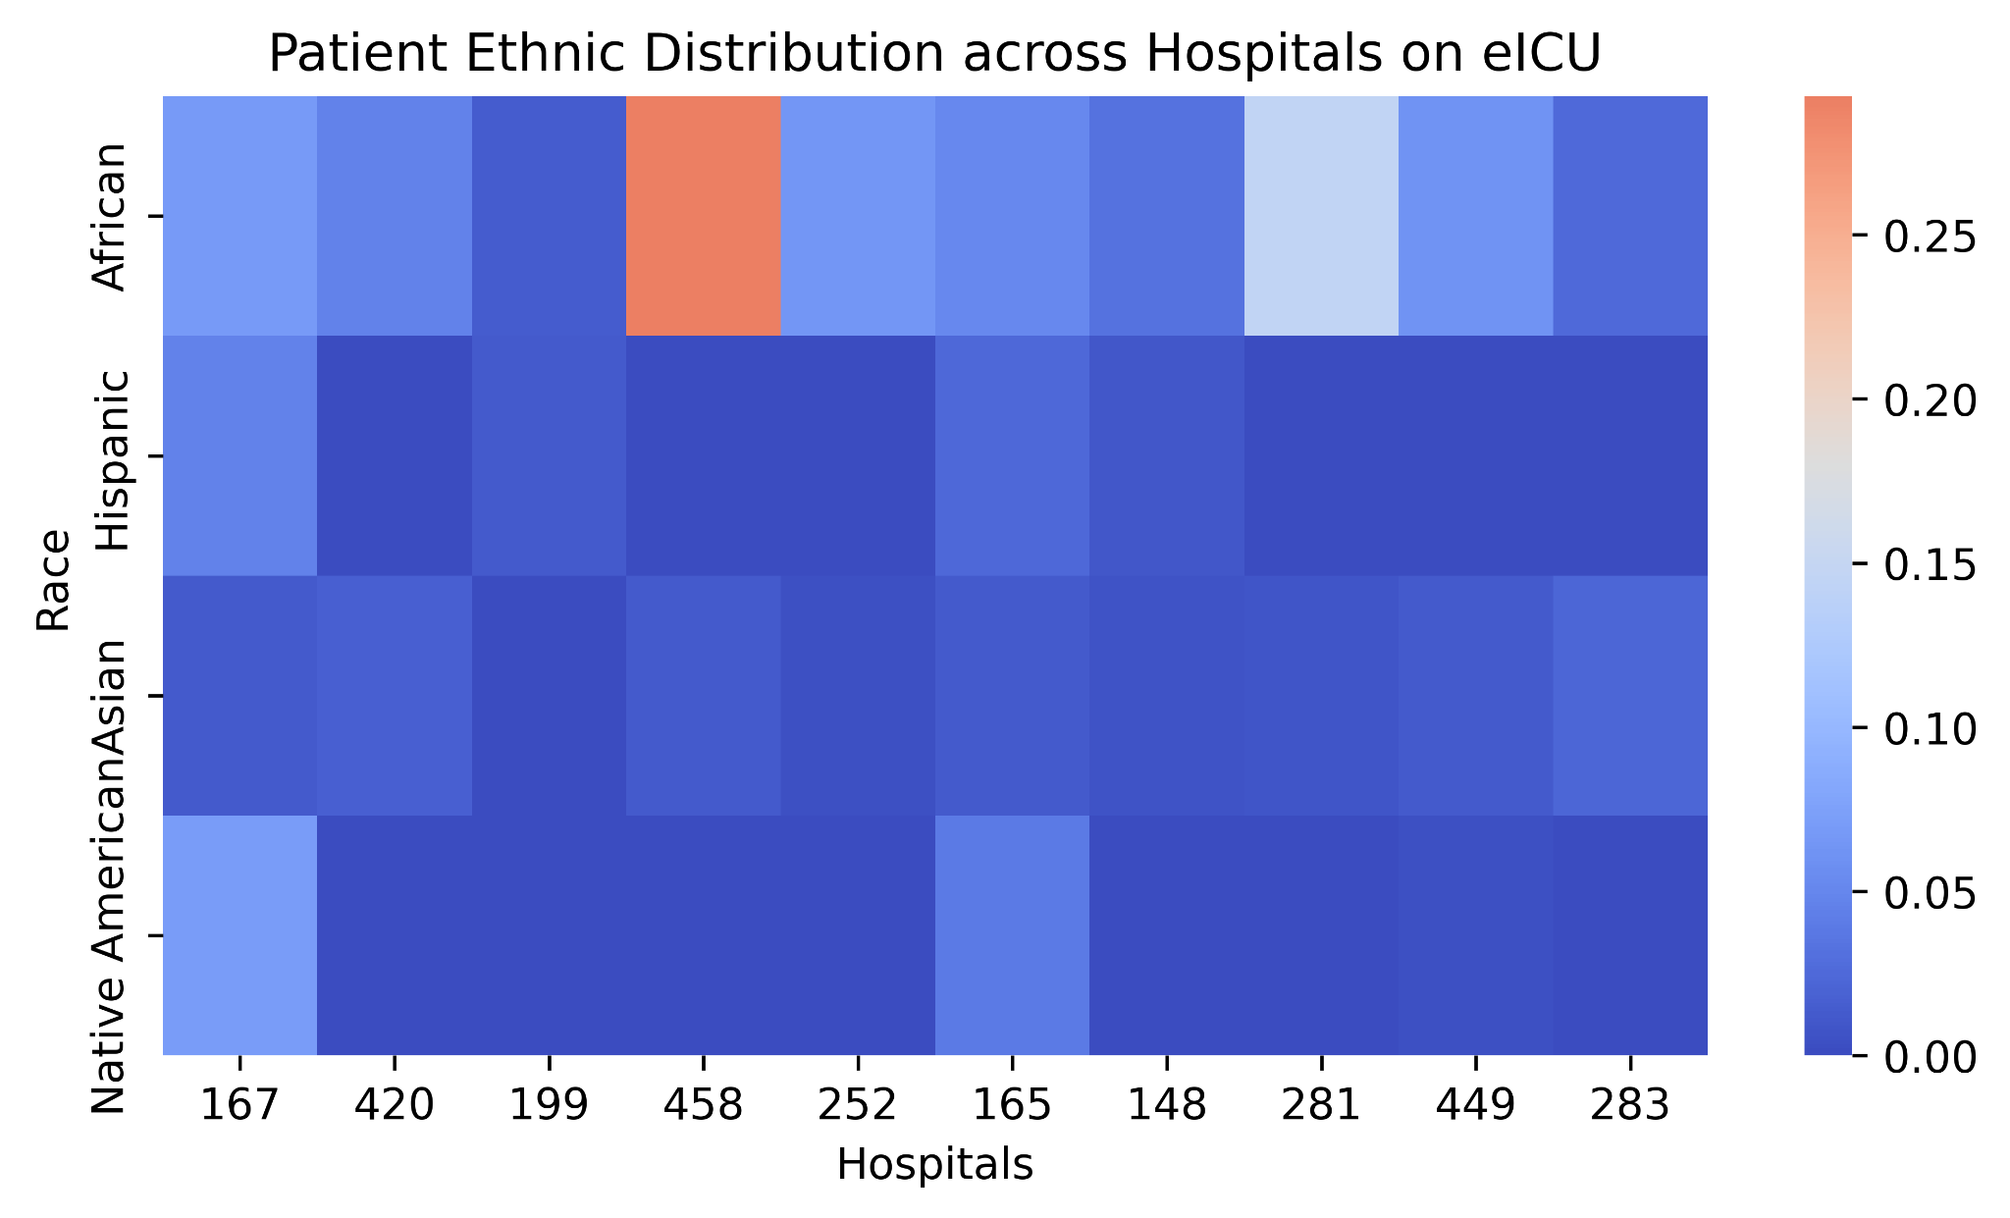

Figure 1. Demographic heterogeneity across the 10 analyzed hospitals based on age, BMI, and sex distributions.

Preprocessing Details
- Hospital and Patient Selection: Records were restricted to the selected eICU hospitals and valid ICU stays. The prediction target was in-hospital mortality.
- 48-Hour Observation Window: Only clinical information available within the first 48 hours of ICU admission was used to construct patient features.
- Demographic Processing: Demographic variables such as age, sex, race, and BMI were cleaned and converted into model-compatible categorical or numerical representations.
- Laboratory Feature Processing: Selected laboratory measurements recorded within the first 48 hours were aggregated at the patient level. Missing laboratory values were imputed using the corresponding median values.
- Medication Processing: Medication records were harmonized using available drug names and identifiers. Only medications administered or recorded within the first 48 hours of ICU admission were retained to prevent the inclusion of information from later stages of hospitalization.
- Clinical Indicator Extraction: Sepsis and ventilation-related indicators were derived from the available diagnosis and treatment records.
- Diagnosis and Treatment Representations: Diagnosis and treatment information was processed into structured feature representations. In the extended feature setting, their temporal patterns were further captured using time-series embeddings.
Final Feature Construction: The processed demographic, laboratory, medication, clinical indicator, and diagnosis/treatment features were combined into patient-level representations for federated training and evaluation.

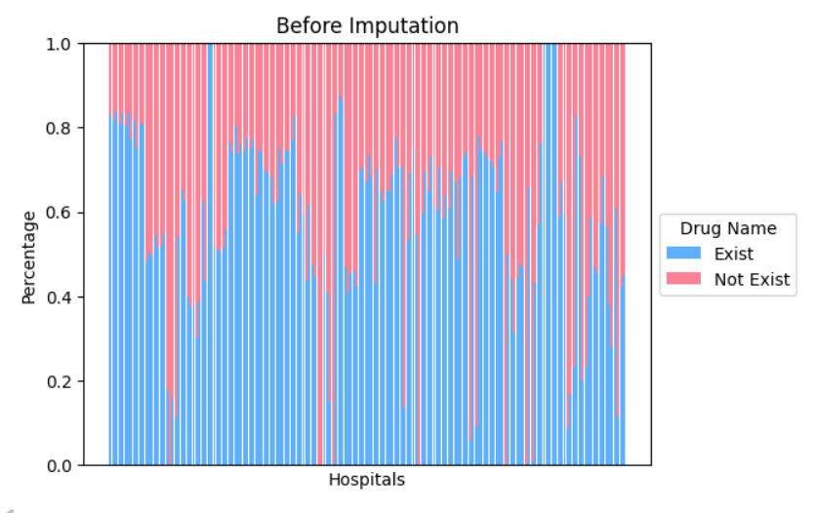 | 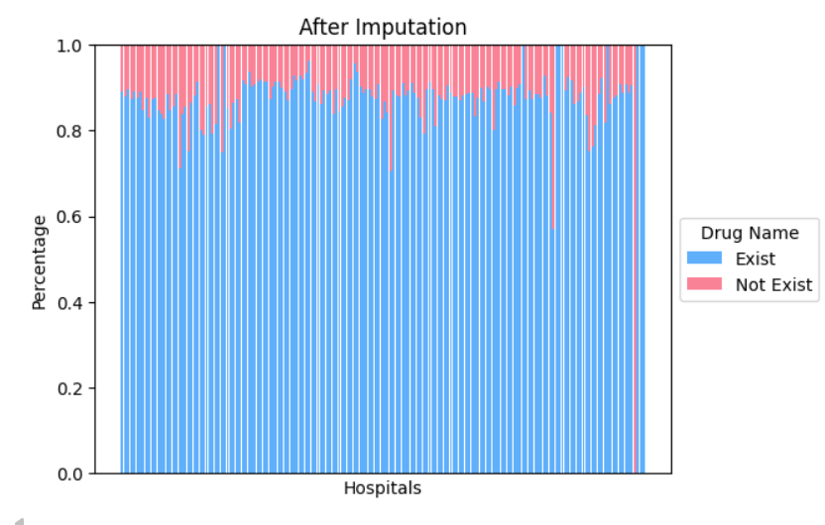

Treatment Embeddings (for Ablation):
Treatment records were first organized hierarchically based on the available treatment categories. Each patient's treatment events within the observation window were mapped to discrete temporal bins, producing a multi-hot representation of treatment activity over time. To obtain compact patient-level representations, the resulting treatment sequences were processed using a neural embedding model that projected the high-dimensional temporal treatment patterns into a lower-dimensional latent space. The learned treatment embedding captures both the presence of specific treatment categories and their temporal evolution during the early ICU stay. These embeddings were subsequently concatenated with the remaining clinical features.

Diagnosis Embeddings (for Ablation):
Diagnosis records were similarly transformed into structured temporal sequences. Diagnosis events were mapped to diagnosis categories and assigned to temporal bins within the observation window, resulting in patient-specific multi-hot sequences. A neural representation model was then used to encode these sparse, high-dimensional sequences into fixed-length latent embeddings. The resulting diagnosis embeddings capture co-occurrence and temporal patterns of clinical conditions during the early ICU stay and were incorporated into the final patient-level feature representation.

General Experimental Settings
The following settings were used as the common experimental configuration for the RQ1 and RQ2 comparisons.
Parameter | Setting
Dataset | eICU Collaborative Research Database (eICU-CRD)
Prediction Task | In-hospital mortality prediction
Client Hospitals | 167, 199, 252, 420, 458
Evaluation Protocol | Strict Leave-One-Hospital-Out (LOHO)
Non-personalized Methods Split | 80% Training / 20% Testing
Personalized Methods Split | 60% Training / 20% Validation / 20% Testing
Federated Rounds | 25
Local Epochs | 5
Batch Size | 256
Optimizer | AdamW
Base Learning Rate | 1.5 × 10⁻³
Learning Rate Schedule | Cosine Decay
Local Weight Decay | 1 × 10⁻⁴
Evaluation Metrics | AUROC, AUPRC, F1-score, Precision, Recall
Random Seed | 42
For non-personalized federated methods, each client's data was divided into 80% training and 20% testing. For personalized methods, the data was divided into 60% training, 20% validation, and 20% testing. All methods were evaluated under the strict LOHO protocol, where each participating hospital was held out in turn as an unseen test hospital, and results are reported as mean ± standard deviation across the held-out hospitals.

HyperParameter Settings:

Hyperparams for FALCON model
Hyperparameter | Value
Random seed | 42
Federated rounds | 25
Local epochs | 5
Batch size | 256
Base learning rate | 1.5 x 10^-3
Learning rate schedule | Cosine decay
Minimum LR fraction | 0.1
Optimizer | AdamW
Local weight decay | 1 x 10^-4
Encoder hidden dimension | 64
Token dimension | 16
Number of ResNet blocks | 2
Dropout | 0.2
Focal loss γ | 2.0
Supervised contrastive weight | 0.05
Contrastive temperature | 0.2
Prototype alignment weight | 0.05
FedProx coefficient | 1 x 10^-4
Gradient clipping | 1.0
SWD projections | 128
Maximum SWD samples | 1024
SWD similarity parameter β | 2.0
Meta-aggregator learning rate | 1 x 10^-4
Meta-aggregator weight decay | 1 x 10^-2
Aggregator temperature τ | 2.0
Weight smoothing factor | 0.10
Maximum client weight | 0.35
Meta gradient clipping | 0.5
Bootstrap iterations | 100

FALCON was trained for 25 federated communication rounds, with five local epochs per round and a batch size of 256. Local optimization used AdamW with a base learning rate of 1.5 x 10^-3 and cosine learning-rate decay. The Tabular ResNet encoder used a hidden dimension of 64, token dimension of 16, two residual blocks, and dropout of 0.2. Focal loss (γ=2.0), supervised contrastive learning (weight 0.05, temperature 0.2), prototype alignment (weight 0.05), and FedProx regularization (μ=10^-4) were used during local training. SWD was computed using 128 random projections, while the convolutional meta-aggregator used a temperature of 2.0, smoothing factor of 0.10, and a maximum client weight of 0.35.

